FOUNDATION DIPLOMA  DEGREE  MASTER

*Please tick* ✓ *or click if using MS WORD*

**Marks Breakdown**

Signature: **Total**

**For office use only** – Lecturer comments (if applicable)

Signature: **Total**

*I/We declare that:*

* *This assignment is my/our own original work, except where I/we have appropriately cited the original source.*
* *This assignment or parts of it has not previously been submitted for assessment in this or any other subject.*
* *I/We allow the assessor of this assignment to test any work submitted by me/us, using text comparison software for plagiarism.****(For more information, Please read the Academic Integrity Guidelines)***

**Name : Joshua Yeoh Keat Keong  
Student ID: 0135760  
Email : 0135760@kdu-online.com  
Mobile No: 0122612488 | Signature:  
Date: 8/12/2022**

Assignment Coversheet **Please complete all details required clearly.** For softcopy submissions,please ensure this cover sheet is included at the start of your document or in the file folder.

**Assignment & Course Details:**

|  |  |  |  |
| --- | --- | --- | --- |
| **Subject Code:** *(e.g. XCAT1234)* **XBGD10033N** | | **Subject Name** *(e.g. Fundamentals of Computing*)**:  Fundamentals of Game Technology** | |
| **Course** *(e.g. Bachelor in Computing)* : Bachelor of Game Development (Hons) | | | |
| **Lecturer Name:** Yap Chin Kein | | | |
| **Assessment Due Date:** *(dd/mm/yy)* | 9/12/22 | **Assessment Title:** | Platformer Game |

SCCM/CSForm/Rev. Ver 2.4

**Name :  
Student ID:  
Email :  
Mobile No: Signature:  
Date:**

**Name :  
Student ID:  
Email :  
Mobile No: Signature:  
Date:**

**Name :  
Student ID:  
Email :  
Mobile No: Signature:  
Date:**

**Name :  
Student ID:  
Email :  
Mobile No: Signature:  
Date:**

**Name :  
Student ID:  
Email :  
Mobile No: Signature:  
Date:**



**Screenshots**

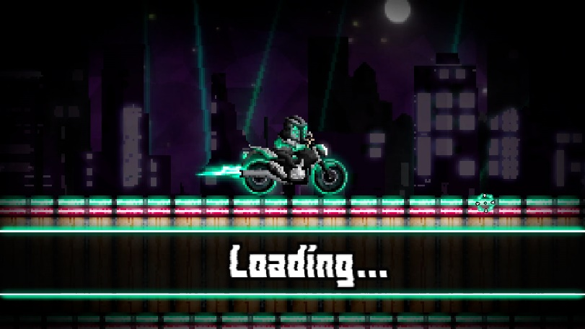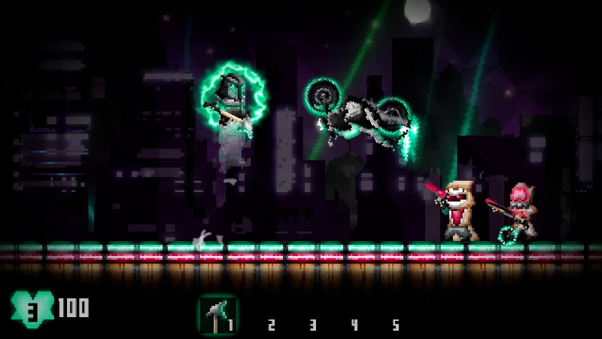

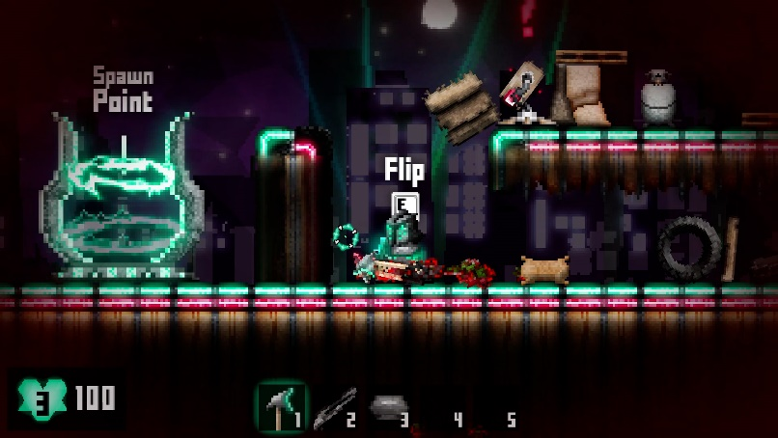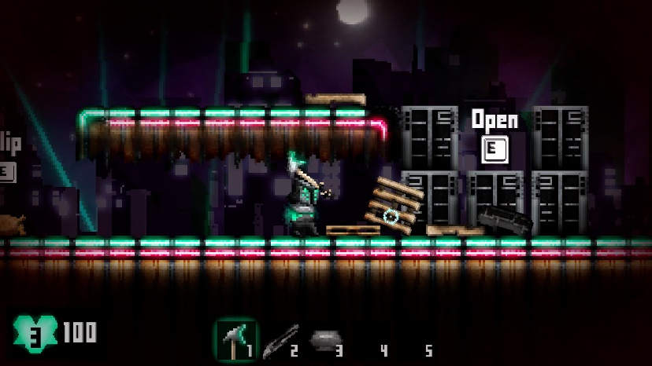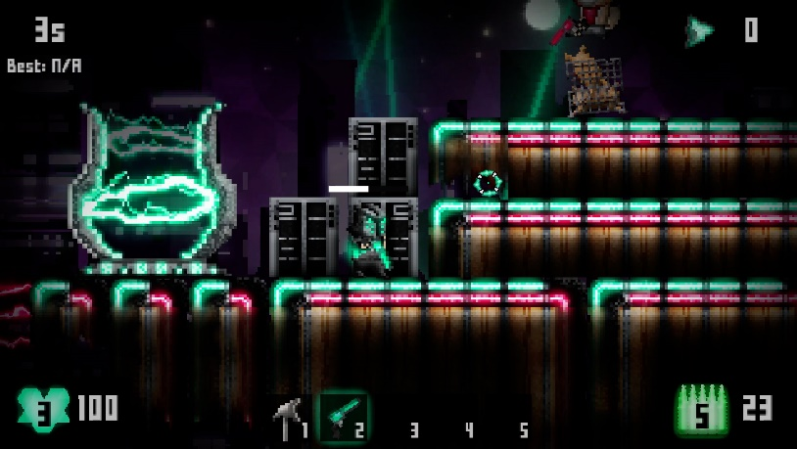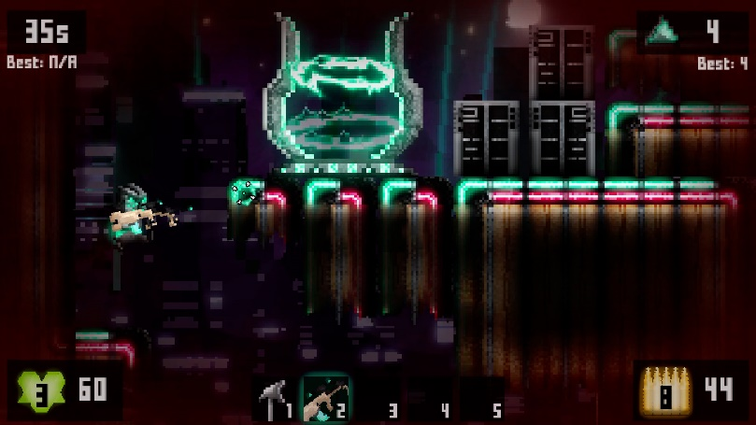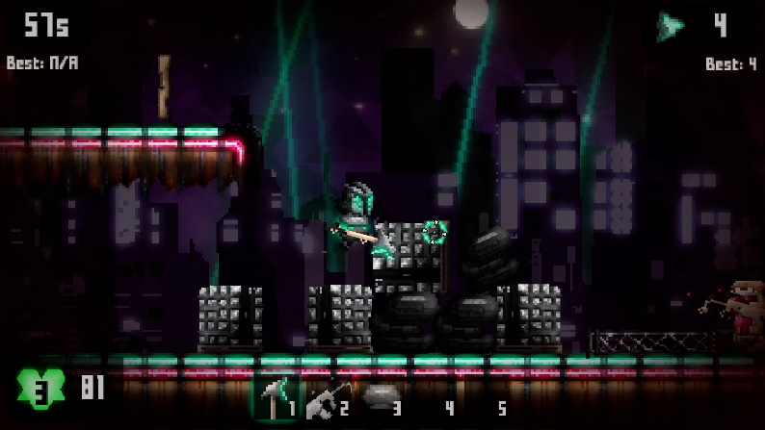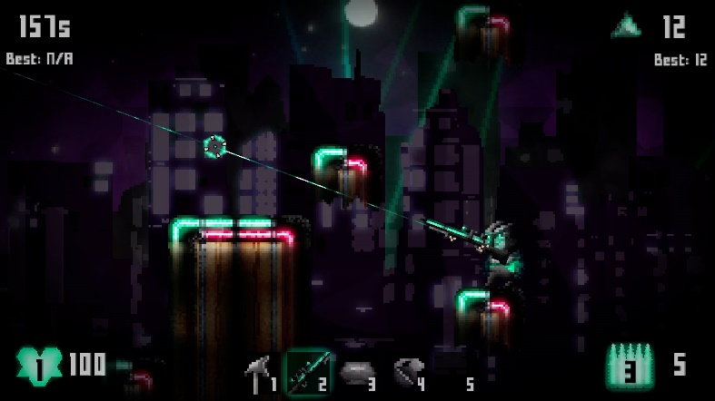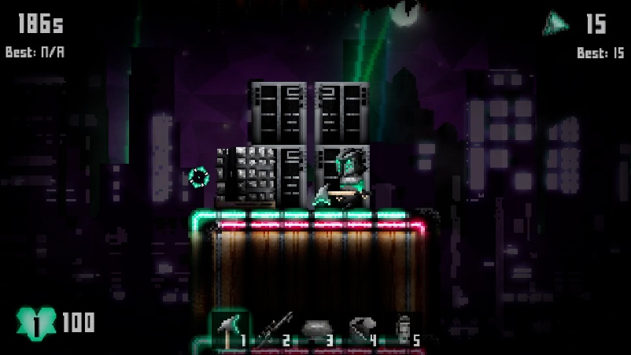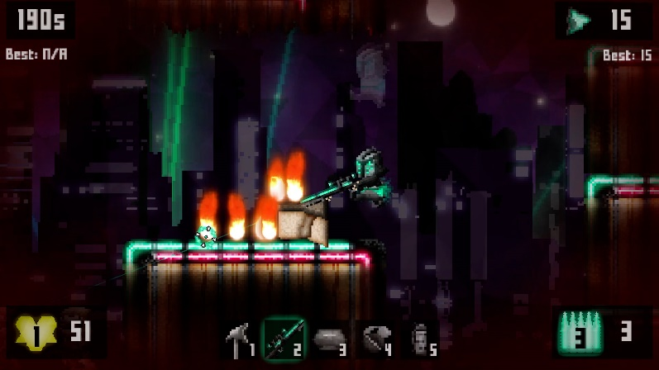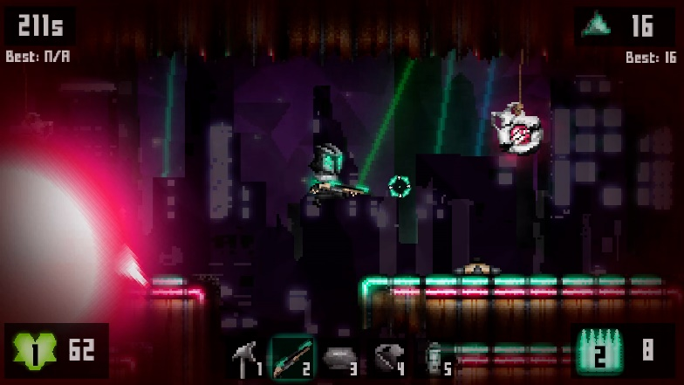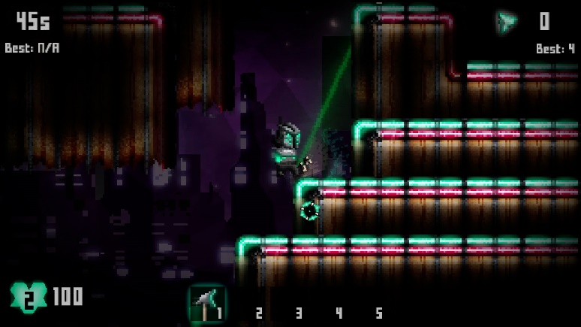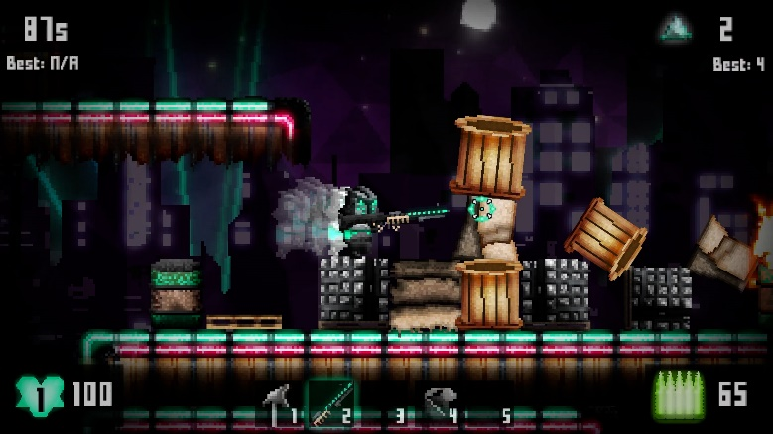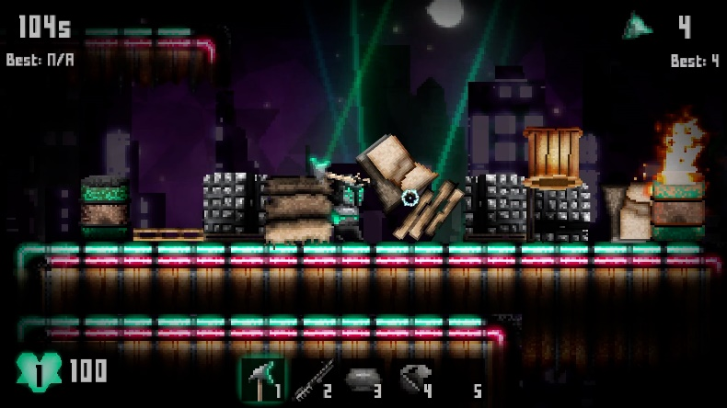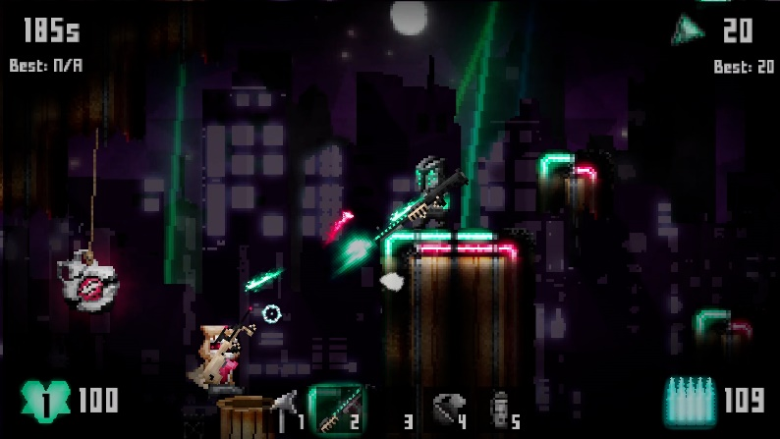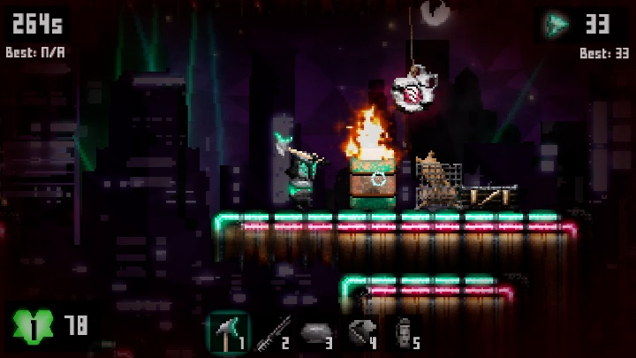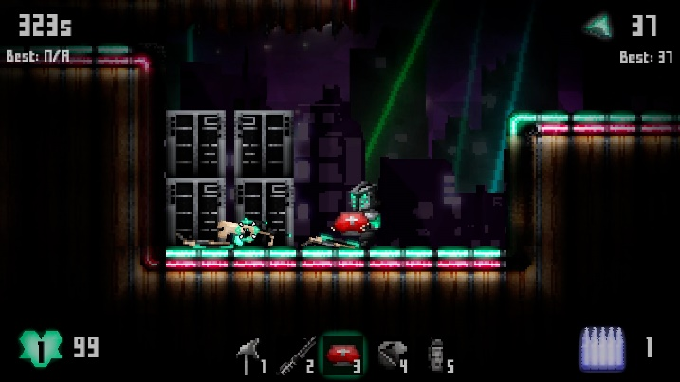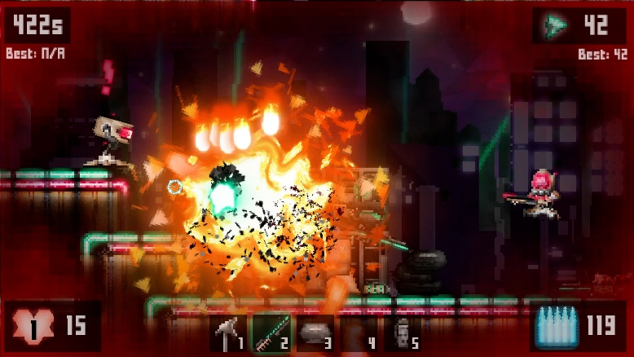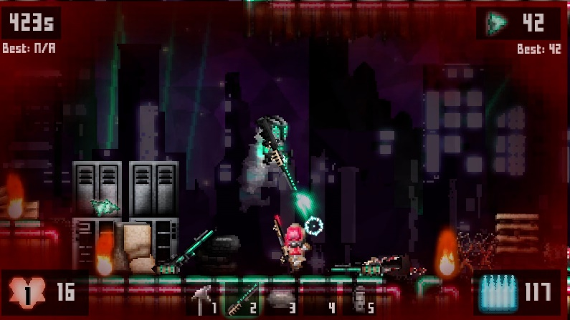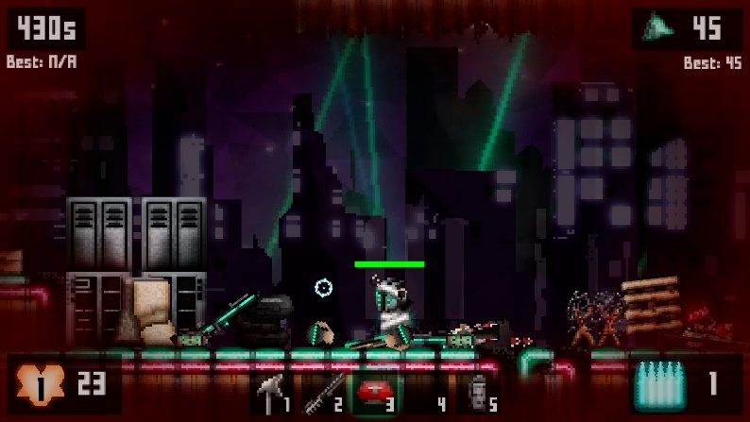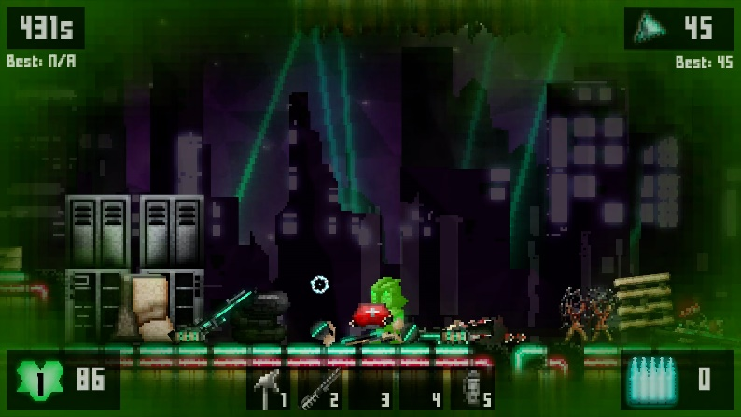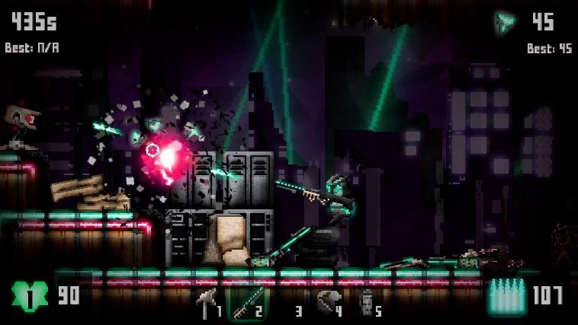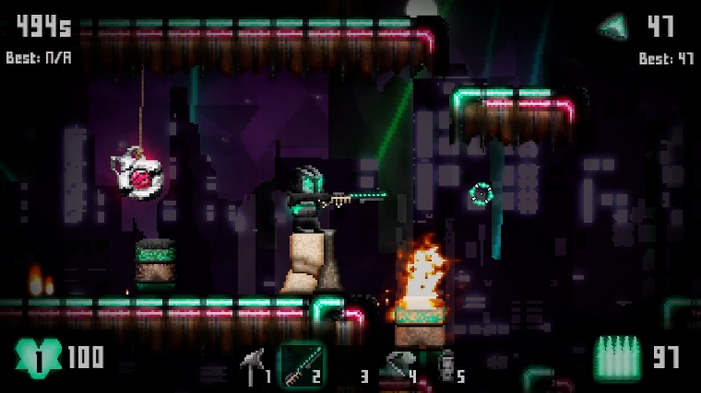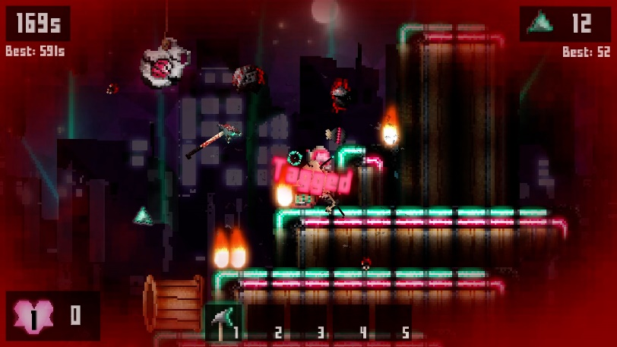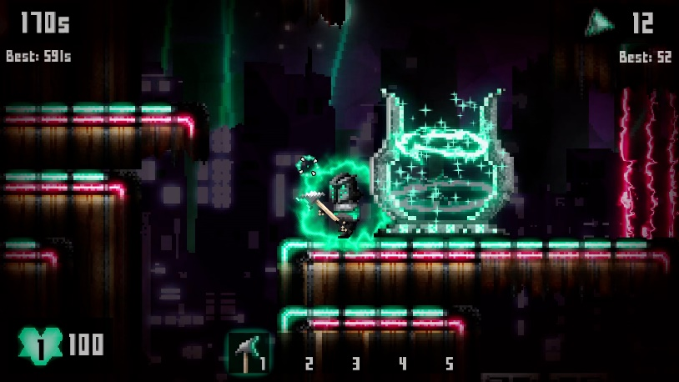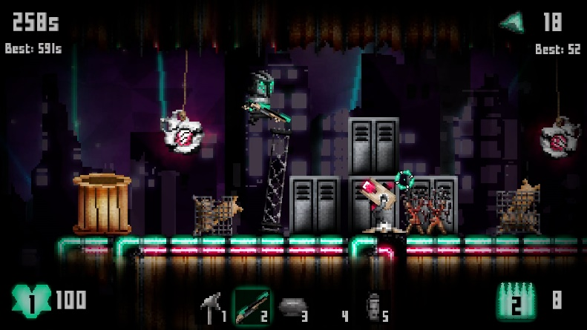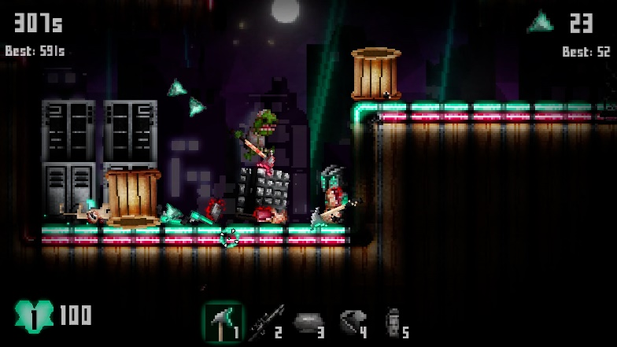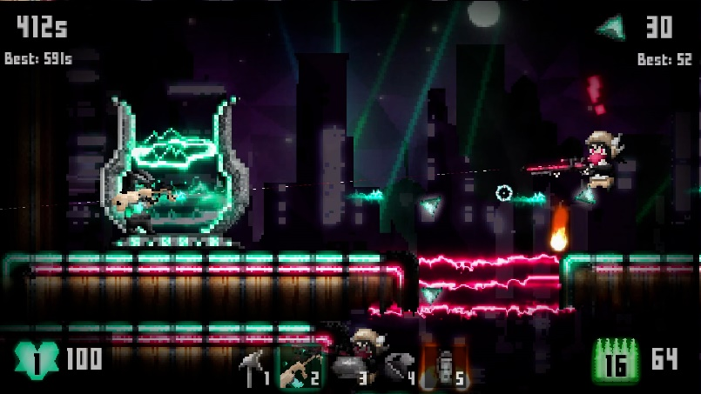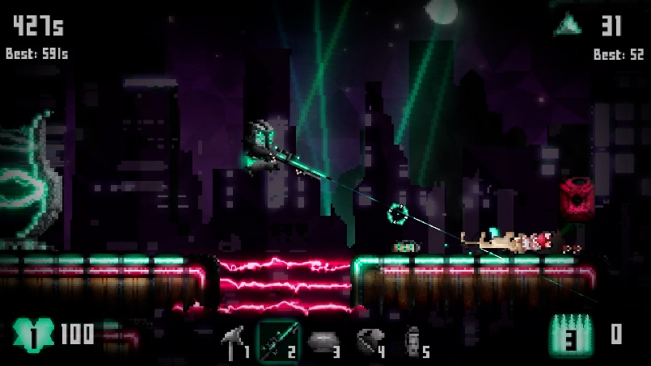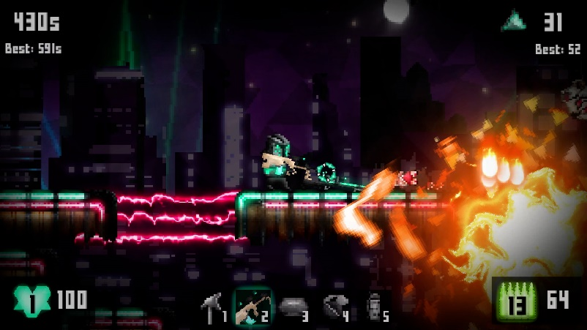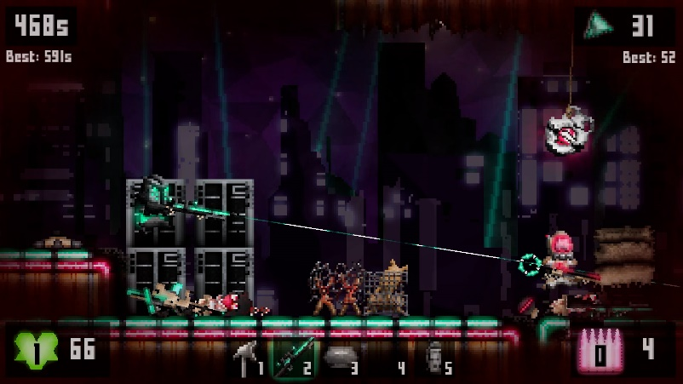

**Controls**

|  |  |
| --- | --- |
| **Input** | **Action** |
| A or Left Arrow | Run Left |
| D or Right Arrow | Run Right |
| Space | Jump |
| E or Enter | Use |
| Q | Parry with Axe |
| R | Reload Gun |
| Mouse | Aiming |
| Left Click | Shoot/Swing/Throw/Heal |
| 1, 2, 3, 4 ,5 | Select Slots 1 to 5 |
| ~~Numpad 0~~ | ~~Noclip~~ |
| Esc/P/Tab/~ | Pause Menu |

**About/Rules**

PlatTAG is a Shooting Action Platformer Game

* Player must explore 3 levels and find an exit portal to progress
* They have to find levers and activate them to open the way to the exit
* Player has to reach the exit portal of the 3rd level to win the game
* There is a Timer that records the time taken to win and records the best time
* Each round of any level will spawn props and enemies randomly around the map

The Player:

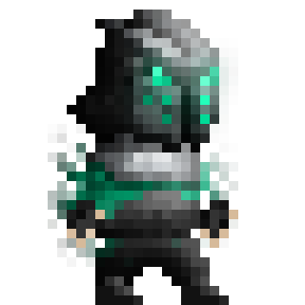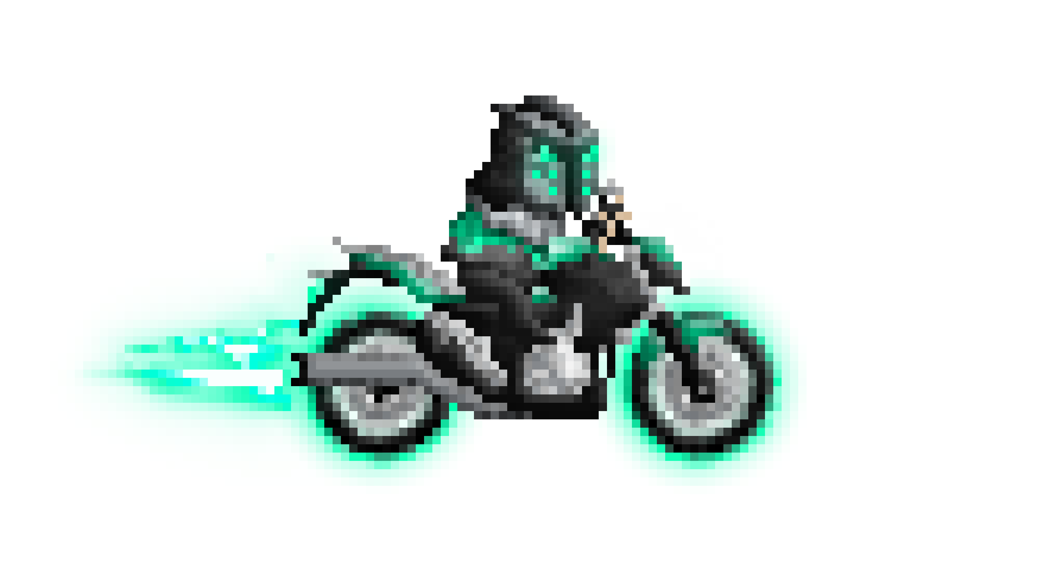

* This is the character sprite of the player
* He is able to double jump
* Each jump is one tile high
* Holds up to 5 five items: Axe, Gun, Medkits, Grenades, and Flashbangs

Player HP:

* The player starts with 3 lives, and 100 Hit points
* Player loses lives when HP hits 0
* When they die, they drop all items from inventory, except the default Axe
* They respawn in the starting portal with 3 seconds of immunity
* Lives and HP continues to the next levels
* 1 HP is regenerated every second



Player Score:

* Scores in the form of glowing blue triangle Dorito chips
* Randomly drops from breaking stuff and enemies’ faces.
* The Highscore is recorded regardless of if Player wins or not
* When dropped, it hovers in the air and disappears after a few seconds
* If the player is near, it will be attracted to the player like a magnet

Player Weapons:

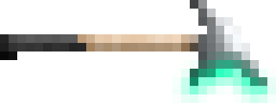

Axe:

* The default starting weapon
* Deals 50 damage
* Normal Look Distance
* It can parry and reflect bullets if timed right



.357 Revolver:

* Deals 34 damage
* 6 rounds in the chamber
* 2 second reload
* Normal fire rate
* Medium accuracy
* Normal Look Distance
* Can be looted from lockers and enemies

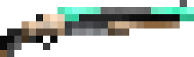

Double Barrelled Shotty:

* Shoots 5 pellets
* Each pellet deals 20 damage
* Hold only 2 shells
* 2 second reload
* Normal fire rate
* Low accuracy
* Normal Look Distance
* Can be looted from lockers and enemies

Steyr AUG:

* Deals 25 damage
* 20 Bullet Magazine
* 2 second reload
* High fire rate
* High accuracy
* Far Look Distance
* Can be looted from lockers and enemies

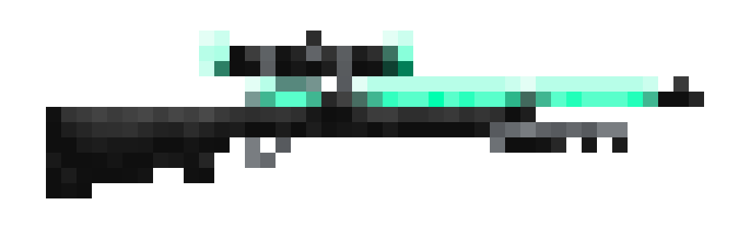

M700 Sniper:

* Deals 50 damage
* 3 Bullet Magazine
* 3 second reload
* Very low fire rate
* Very High accuracy
* Very Far Look Distance
* Can shoot through walls
* Can be looted from lockers and enemies

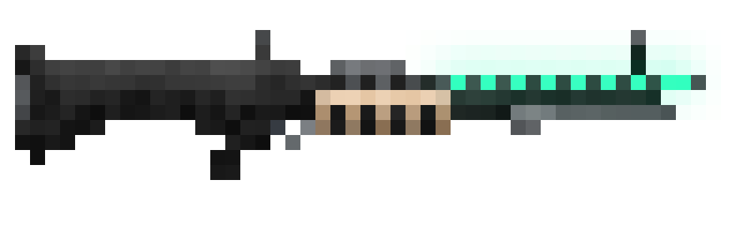

M60 Machine Gun:

* Deals 34 damage
* No Reloads
* Very High fire rate
* Normal accuracy
* Normal Look Distance
* Can be looted from lockers and enemies

Items:



Medkit:

* Heals 80% of damage taken
* 3 seconds healing time
* Player is unable to move and jump when healing
* Can be cancelled mid heal
* Can be looted from lockers

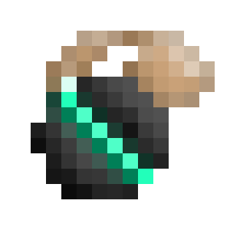

Cluster Grenade:

* Explodes after 2 seconds
* Deals 50 damage
* Shoots 4 additional shrapnel after exploding
* Shrapnel causes smaller explosions
* Deals 25 damage each

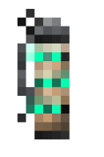

Flashbang:

* Explodes after 1 second
* Disables humanoid enemy attacks and detection for 3 seconds
* If thrown by enemies, Blinds and deafens the player for 3 seconds
* Face away to avoid flash

Enemies:

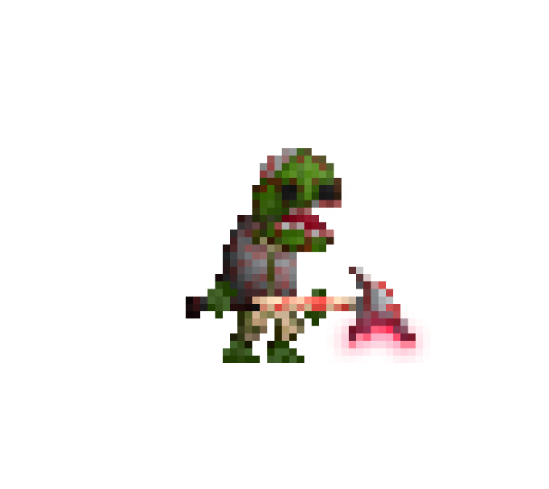

Zombie:

* 100 HP
* Normal Speed
* Wanders when idle
* Chases the player when in range
* Will attempt to jump if blocked by tiles and props
* Tries to jump to dodge when shot at
* Tries to parry player’s axe and bullets
* Attacks when near, Deals 50 damage

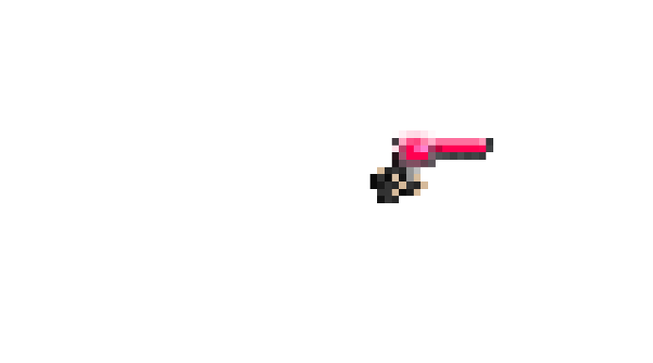

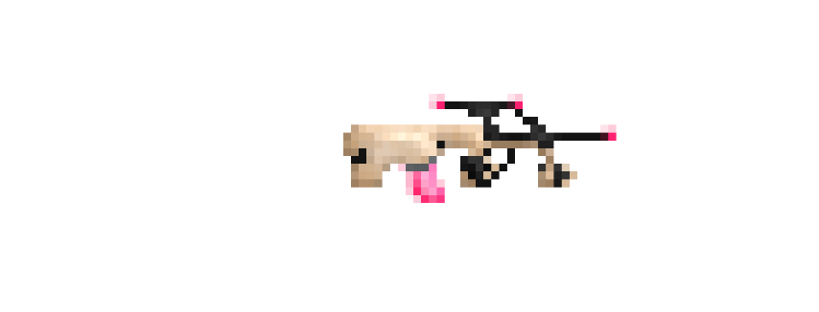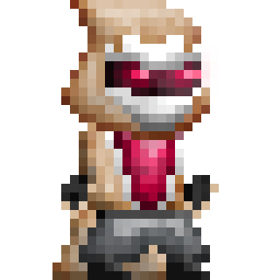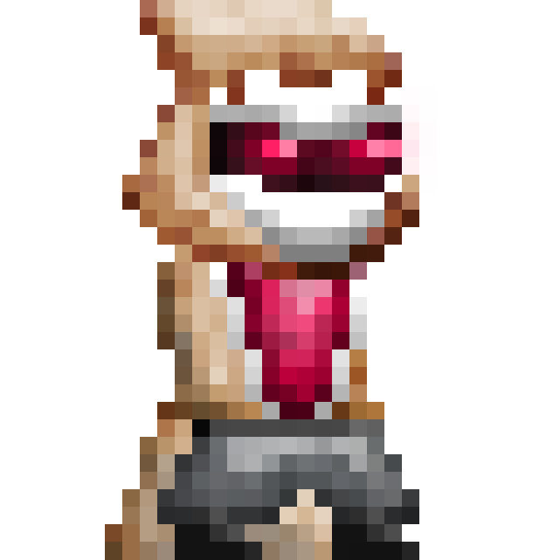

Light Gunner:

* 100 HP
* Normal Speed
* Wanders when idle
* Chance to spawn with .357, Shotty, or AUG
* Aims and Shoots at the player when in range
* Will attempt to jump if blocked by tiles and props
* Tries to jump to dodge when shot at
* Drops gun when killed

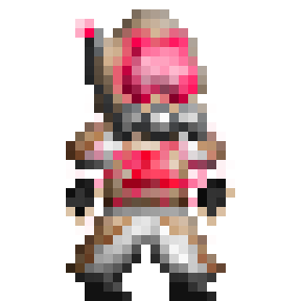

Heavy Gunner:

* 200 HP
* Slow Speed
* Wanders when idle
* Chance to spawn with Shotty, AUG, or M60
* Aims and Shoots at the player when in range
* Throws a grenade every few seconds
* Will attempt to jump if blocked by tiles and props
* Tries to jump to dodge when shot at
* Drops gun when killed
* Chance to drop a grenade

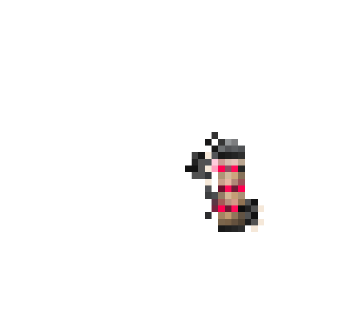

Sniper:

* 100 HP
* Normal Speed
* Wanders when idle
* Spawns with M700 Sniper
* Aims and Shoots at the player when in range
* Very long detect range
* Shoots through walls
* Throws a flashbang every few seconds when player is close
* Drops gun when killed
* Chance to drop a flashbang

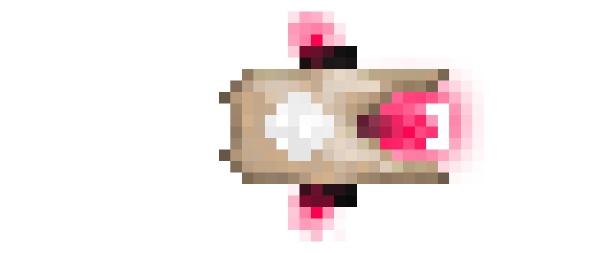



Sentry Gun:

* 200 HP
* Stationary
* Looks around when idle
* Aims and Shoots at the player when in range
* Fires a homing missile every few seconds, creates a small explosion on contact
* Deals 25 damage
* Creates a big explosion when killed
* Deals 50 damage

Props:

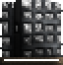

Big Props:

* 200 HP



Medium Props:

* 100 HP
* Breaks into smaller props



Small Props:

* 50 HP

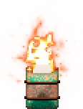

Painful Props:

* 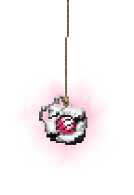200 HP
* Deals 10 damage on Contact
* Fire Barrel drops flames

    

Explosive Props:

* Causes large explosion when damaged
* Deals 50 damage
* Drops flames
* Deals 10 damage on Contact
* Hanging lamps fall when rope is cut
* Explodes on hitting the ground

 

Mine:

* Beeps for 2 seconds when Player is near
* Then Explodes and shoots shrapnel

 

Locker:

* Provides supplies once
* 50% chance to be empty on spawn
* Chance to drop Guns, Medkits, Grenades, or nothing

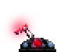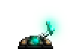

Lever:

* Toggles gates on and off



Gate:

* You shall not pass
* Deals 10 damage on Contact



Teleporter:

* Serves as the starting and ending points of each level
* Provides iFrame for the player for 3 seconds on respawn

**Game Objects**

|  |  |  |  |  |  |  |
| --- | --- | --- | --- | --- | --- | --- |
| **Player** | **Enemy** | **Items** | **Props** | **Decals** | **Misc** | **Behaviours** |
| Player | Zombie | ItemChip | Barrel Fire | PlayerBullet | Equipment Slots | Cannot Exit Sides |
| PlayerArms | Light | ItemGun | Barrel Fire Sensor | EnemyBullet | HUD Boxes | Die on Leaving Scene |
| ItemSensor | Heavy | ItemUtil | Gate | EnemyFlashbang | HUD Icons | HPManager |
| Cameraman | Sniper |  | Lever | EnemyGrenade | Tutorial Instructions | HPManagerPlayer |
| Shield | SniperCorpse |  | Locker | EnemyGrenadeShrap | Alert | LeverActivate |
| PlayerAxeHitbox | SentryGunBody |  | Mine | EnemyM700Bullet | Buttons | Standard Actor Behavior |
| PlayerParrybox | SentryGunhead |  | OilLamp | ExplosionDeco | ButtonTexts | Z Index |
| MotionBlur | Enemy arms |  | PropBig | ExplosionEnemy | Crosshair | Audio |
| PlayerBike | Enemy axe hitbox |  | PropExplosive | ExplosionFire | DeathStrip | HUD |
|  | EnemyParrybox |  | PropHurt | ExplosionPlayer | FlashOverlay | LoseMenu |
|  | ZombieArms |  | PropMed | Flame | LoadingStrip | PauseMenu |
|  | Sniper Arms |  | PropSmall | Gibs | PauseBG | Standard Scene Behaviour |
|  |  |  | Teleporter | PlayerFlashbang | PauseStrip | TutorialScene |
|  |  |  | TeleporterExit | PlayerGrenade | Road |  |
|  |  |  |  | PlayerGrenadeShrap | Tagged |  |
|  |  |  |  | PlayerM700Aim | Tutorial Tickbox |  |
|  |  |  |  | PlayerM700Bullet | Title |  |
|  |  |  |  | SentryGunRocket | TransitionOverlay |  |
|  |  |  |  |  | WinStrip |  |

**Credits:**

Stencyl

Adobe Photoshop – Art

Adobe After Effects – Animations & VFX

Various video games – Sound Effects

Audacity – Audio Converting/Editing

MP3 tag

The Night Comes For Us – Night Club Fight OST

CryNN – Hyperior

Hotline Miami OST

Irving Force – Sewer Wars

Megadrive – Video Stalker

**Pseudocodes:**

The Player pseudocode

When created:

* Face Right
* Move Enabled
* Jump enabled
* Create Scale X and Y var and set to 100 for both
* Set speed var to 20
* Set jump var to 40
* Play Idle animation
* Face mouse enabled
* Aim mouse enabled
* Spawn player arms, assign to actor attr
* Spawn item sensor, assign to actor attr
* Camera on player enabled
* Set camera range var to 4
* Scope enabled
* Set heal timer var to 0
* Set jump count var to 2
* Last selected weapon should be axe
* Current selected weapon should be axe
* Change animation of arms to axe idle
* Enable iframe for 3 seconds, create shield
* Create a M700 aim actor but hide it for later use and assign to actor attr

Looking at mouse:

* Always grow player and arms to scale x and y var, which is 100 at first
* If mouse is left of player
  + Set scale x to -100
  + Otherwise, set to 100
* If scale x is less than 0
  + Player is not facing right
  + Otherwise, player is facing right
* If player is facing right
  + Aim arms at the mouse
  + If facing left, then add 180 degrees to offset the angle
* If aim mouse var is false, point arms in front at 0 degrees

Moving:

* Make arms and item sensor follow the player x and y
* If right button is down
  + Positive x speed
  + If facing right, play run animation
  + Otherwise, play runback animation
* Otherwise If left button is down
  + Negative x speed
  + If facing right, play runback animation
  + Otherwise, play run animation
* Otherwise, 0 x speed and play idle animation

Jumping:

* If jump button was pressed
  + Jump count must be more than 0
  + Set jump count to 2 when on the floor
  + Minus 1 jump count
  + Set y speed to 0 first to counter gravity, to make jump height consistent
  + Push player up with jump force
  + Play jump animation
  + If jump button was pressed again, Double jump on the last jump count, minus 1 jump count, 0 remaining
  + Do motion blur effect on double jump
  + If player is falling but didn’t jump before, set jump count to 1

Switching equipment selections:

* Action must be true
* If 1 is pressed, and not selected axe
  + set selection to axe
  + Play axe idle anim for arms
  + Enable aim mouse
* If 2 is pressed, and not selected gun, and magazine or reserve ammo must be more than 0
  + Set selection to gun
  + Play gun idle anim for arms
  + Gun idle anim name depends on the name of current type of gun
  + Enable aim mouse
* If 3 is pressed, and not selected Medkit, and Medkit ammo is more than 0
  + Set selection to Medkit
  + Play Medkit idle anim for arms
  + Disable aim mouse
* If 4 is pressed, and not selected grenade, and grenade ammo is more than 0
  + Set selection to grenade
  + Play grenade idle anim for arms
  + Enable aim mouse
* If 5 is pressed, and not selected flashbang, and flashbang ammo is more than 0
  + Set selection to flashbang
  + Play flashbang idle anim for arms
* If ammo runs out while having gun selected
  + Change to axe
* If Medkit, grenade, or flashbang runs out while having them selected
  + Change to gun if that was the last selected
  + If no ammo then change to axe
  + If last selected was axe, then just change to axe instead of gun

Doing actions:

* Action must be true
* For axe, If mouse is down
  + Disable action
  + Play axe swing anim for arms
  + In the middle of the animation, create invisible axe hitbox
  + scale that hitbox to scale x and point to mouse
  + the hitbox will disappear by itself after animation
  + After that, enable action again
  + Play axe idle anim for arms
* For axe, if parry button is pressed
  + Disable action
  + Play axe parry anim for arms
  + Create invisible parry box
  + Aim parry box to mouse and scale to scale x
  + Make parry box follow the player x and y
  + After animation, kill parry box and disable parrying bool
  + Enable action
* For any gun except M700, if mouse is down
  + Disable action
  + Play gun shoot anim for arms
  + Set inaccuracy according to type of gun
  + Create bullet
  + Match bullet anim according to type of gun
  + Point bullet at mouse plus or minus accuracy
  + Set velocity of bullet to 100 at direction of mouse
  + Minus 1 ammo from ammo mag
  + After animation, enable action, play gun idle anim for arms
* For M700 gun, if mouse is down
  + Disable action
  + Play m700 shoot anim for arms
  + Minus 1 ammo from ammo mag
  + Set inaccuracy to 1 degree
  + Create m700 bullet
  + Point it at mouse plus minus inaccuracy
  + The m700 bullet will disappear by itself
  + After animation, enable action, play m700 idle anim for arms
* For any gun except m60, if reload button is pressed, or run out of ammo while mouse is down
  + Ammo magazine must be lower than ammo magazine max
  + Disable action
  + Play gun reload anim for arms
  + Disable aim mouse
  + Set reload timer to 0
  + Do every 0.1s, increase reload timer by 0.1
  + Once reload timer hits 2 seconds (3 seconds for M700), cancel the repeater
  + Set reload timer back to 0
  + Enable action
  + Play gun idle anim for arms
  + Enable aim mouse
  + If ammo reserve is less than the difference between ammo mag max and ammo mag,
    - Transfer all remaining ammo reserve to ammo mag
    - Set ammo reserve to 0
  + Otherwise,
    - Decrease ammo reserve by the difference between ammo mag max and ammo mag
    - Set ammo mag to ammo mag max
* For flashbang or grenade, if mouse is pressed
  + Disable action
  + Play flashbang or grenade throw anim for arms
  + minus 1 flashbang or grenade ammo
  + Create flashbang or grenade
  + Push it at the direction of mouse with 75 force
  + After animation, enable action, play flashbang or grenade idle for arms
* For medkit, if mouse is down, and not healing, and player HP is not full, and not in mid air
  + Disable action
  + Enable healing bool
  + Set heal timer to 0
  + Stop player from moving and jumping
  + Play medkit use anim for arms
  + Do healing animation for player
  + Do every 0.1s, plus 0.1 to heal timer
  + If mouse was released while healing,
    - Set healing to false
  + If healing is false,
    - Set heal time back to 0
    - Enable action
    - Play idle anim for arms and player
    - Enable move and jump
    - Stop the repeater
  + Otherwise if healing was not interrupted for 3 seconds,
    - Minus 1 medkit ammo
    - restore 80% of the total health loss back to player hp
    - set heal timer to 0
    - set healing to false
    - play idle anim for arms and player
    - enable action
    - enable move and jump
    - Stop the repeater

Picking up guns:

* When item sensor hits a gun item, and use button was pressed
* Action must be true
* If have existing gun, but not the same gun,
  + Create another gun item
  + Match its animation to current gun
  + Empty all the default ammo from that gun
  + Add ammo mag and ammo reserve to that gun
* Set ammo mag max to match the first gun item
* If it’s the same gun currently equipped,
  + Add its ammo reserve and ammo mag to the player’s ammo reserve
* Otherwise, match the player’s ammo mag and reserve to the gun’s ammo mag and reserve
  + Set selection to gun
  + Play gun idle for arms according to the gun item type
  + Enable aim mouse
  + Kill the gun item

Picking up utilities like Medkits, grenades, flashbangs:

* When item sensor hits a util item, and use button was pressed
* If it’s a Medkit, plus 1 medkit ammo
* If it’s a grenade, plus 1 grenade ammo
* If it’s a flashbang, plus 1 flashbang ammo
* Kill util item

Picking up score items:

* When item sensor hits a score item
* Add 1 to score
* Kill score item

When player is killed:

* Set player alive bool to false
* Kill arms
* Kill item sensor
* Kill m700 aim
* Kill axe hit box
* Kill axe parry box
* Kill shield

When detecting that a flashbang has exploded:

* If player faces at the flash bang it is in the camera view,
* Blind and deafen the player

Aiming with the m700:

* Make the m700aim actor attr from earlier follow the player
* Point at mouse
* If m700 is selected, and not reloading, and action is true
  + Unhide it by scaling from 0% width to 100% width
* Otherwise,
  + Hide it by scaling width to 0%

The Zombie pseudocode

Aggro:

* Set distance to a^2+b^2=c^2 with x and y of player and self
* If distance less than aggro range, set aggro to true
* If player exit aggro range, disable aggro and set a 2 second cooldown to aggro again

Moving:

* If aggro is true,
  + If player is right, move right
  + If player is left, move left
* Otherwise if not aggro,
  + Randomly move and stop
  + Randomly face left or right

When hitting a tile, prop, player, enemy:

* If left side hit while moving left, or if right side hit while moving right
  + If aggro, jump
  + If not aggro, just change direction
* If tile is a corner piece
  + If moving, jump after .5 seconds

Swinging axe:

* If player is in attack range, and facing the player
* Do axe attack similar to player’s axe attack

Parrying:

* If facing the player, and mouse is down, and player is holding gun
* Do axe parry similar to player’s axe parry

When flashed by flashbang:

* Set aggro to false
* Set action to false

The Gunner pseudocode

When created:

* Choose a random gun type
* Set ammo, inaccuracy and reload duration according to gun
* Play gun idle anim according to gun for arms
* Set an aggro range
* Set a grenade range
* Set ammo grenade to 1
* Set aim offset for more inaccuracy

Aggro:

* Set distance to a^2+b^2=c^2 with x and y of player and self
* If distance less than aggro range, set aggro to true
* If player exit aggro range, disable aggro and set a 2 second cooldown to aggro again

Aiming:

* Point arms at aim x and y
* If aggro, set aim x and y to player x and y plus minus aim offset
* Otherwise if not aggro, randomly move aim y up or down every few seconds

Shooting gun:

* If player in aggro range
* Randomly toggle shoot Boolean
* If shoot is true, spray bullets until shoot becomes false
* If shoot is true but no ammo, reload
* Similar to player shooting and reload

Throwing grenade:

* If ammo grenade more than 0, and player in grenade range,
* Set action to false
* Play grenade throw anim for arms
* Minus 1 grenade ammo
* Create grenade and push to direction of player with 75 force
* After animation, enable action, play idle anim
* After 5 seconds, plus 1 ammo grenade

The Sniper pseudocode:

Shooting:

* If ammo more than 0,
* Disable action
* Create m700 bullet
* Play aim anim for bullet (no damage, just laser)
* If player is still in aggro range,
  + After few seconds, Stop aiming at player
  + After a few milliseconds, play shoot anim for bullet
  + Minus 1 ammo
  + After animation, play idle anim, enable action
* If player no more in aggro range,
  + Kill bullet (stop laser)
  + play idle anim, enable action

The Homing rocket pseudocode:

* always set velocity to direction self
* spin self to player over .2 seconds
* set homing timer to 1 second
* after 1 second stop homing